SIMATS ENGINEERING
SAVEETHA INSTITUTE OF MEDICAL AND TECHNICAL SCIENCES
CHENNAI – 602105
Department of Computer Science and Engineering

ASSESSMENT TOOL 2 – SCHEMA ANALYSIS AND VIVA VOCE

Course Code: | DSA05 | Course Title: | Query Processing for Data Science With Real Time Applications
CO Assessed: | CO2 | Assessment: | Tool 2 – Schema Analysis and Viva Voce
Weightage: |  | Total Marks: | 20 Marks
CO2 Statement: Use Python basics and SQL libraries to connect to databases SQLite, MySQL, PostgreSQL and perform CRUD operations like Create, Read, Update, Delete. (BTL6)
Student Name: |  | Reg. No.:
Section / Batch: |  | Date of Submission:
Faculty In-charge: |  | Project Mode: | Individual Submission

Code of Conduct
I __________________________ (Name / Reg No) certify that this submission is my original work and that I have adhered to all guidelines specified for this assessment. I understand that any violation of academic integrity rules will result in disciplinary action.
Signature: _________________________

Requirement Analysis (4 Marks) | ER Diagram Design (4 Marks) | Table Design & Normalization (4 Marks) | Database Connectivity using Python (4 Marks) | CRUD Operations (4 Marks) | Total (20 Marks)

SCENARIO 1 – University Student Management System\

- Requirement Analysis

- Store student information in a centralized database.
- Maintain department details.
- Avoid duplicate student records.
- Support Create, Read, Update and Delete (CRUD) operations.
- Generate reports efficiently.

2. ER Diagram

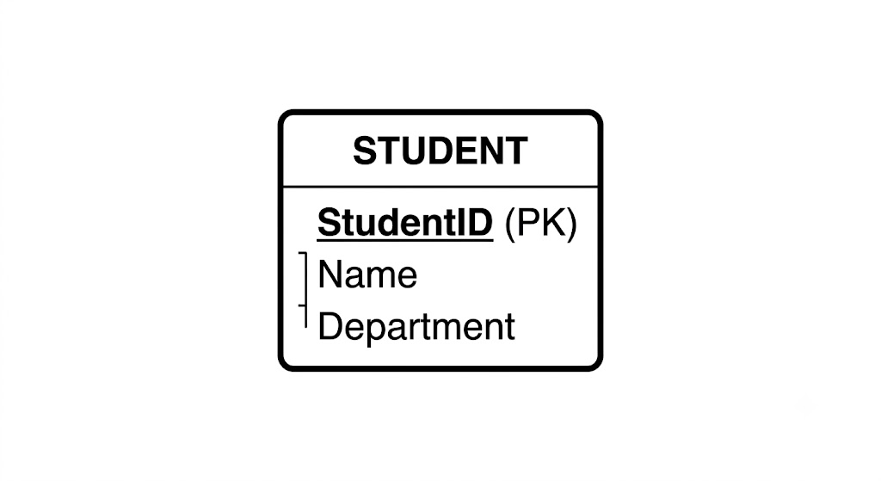

3. Table Design & Normalization

Field Type Key | Type | Key
StudentID | INTEGER | Primary Key
Name | TEXT | -
Department | TEXT | -

4. Database Connectivity using Python
import sqlite3

conn = sqlite3.connect("university.db")
cursor = conn.cursor()

# Create Table
cursor.execute("""
CREATE TABLE IF NOT EXISTS Student(
StudentID INTEGER PRIMARY KEY,
Name TEXT,
Department TEXT
)
""")

# Remove old data (avoids duplicate ID errors)
cursor.execute("DELETE FROM Student")

# CREATE
cursor.execute("INSERT INTO Student VALUES (1,'John','CSE')")
conn.commit()

print("CREATE")
cursor.execute("SELECT * FROM Student")
print(cursor.fetchall())

# UPDATE
cursor.execute("UPDATE Student SET Department='AI' WHERE StudentID=1")
conn.commit()

print("\nUPDATE")
cursor.execute("SELECT * FROM Student")
print(cursor.fetchall())

# DELETE
cursor.execute("DELETE FROM Student WHERE StudentID=1")
conn.commit()

print("\nDELETE")
cursor.execute("SELECT * FROM Student")
print(cursor.fetchall())

conn.close()

5. CRUD Operations – Output

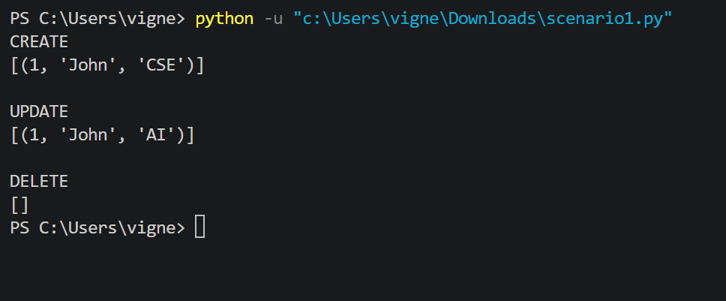

6. Result
Successfully connected Python to the SQLite database and performed Create, Read, Update and Delete (CRUD) operations on the Student table.

